**Final Year Project Proposal**

**AI-Driven Face Analysis**



**Submitted By**

**Dua Batool F22-BSc-IET-001**

**Hajra Nawazish F22-BSc-IET-003**

**Qurat-ul-Ann F22-Bsc-IET-035**

**Supervised By**

**Ms. Afifa Zafar**

**Department of Information Engineering Technology**

**National Skills University Islamabad**

**Session 2024-26**

**Table of Contents**

List of Tables

1. Introduction 3

1.1 Background 3

1.2. Existing Examples / Solutions 3

1.3. Aims and Objectives 6

1.4. Business Scope 9

1.5. Useful Tools and Technologies 10

2. Proposed Methodology 12

3. Project Work Break Down 14

3.1 Project Time-Line 16

References 17

**AI-Driven Face Analysis**

**Final Year Project Proposal**

## Introduction

AI-driven face analysis is a smart technology that can detect human faces and read emotions by analyzing facial expressions. It can tell if someone is feeling emotions like anger, happiness, or politeness and gives a percentage score for each emotion and it can also used for recognition of a person. This helps in better understanding how people feel and can be useful in areas like customer service, mental health, security, and marketing. It allows companies and organizations to improve their interactions with people by knowing more about their emotions.

## Background

In 1960, Bledsoe created a face recognition system that only recognized images. Advances in AI led to the development of algorithms for emotion recognition. Modern systems can identify both faces and emotions, with applications in various fields like security and healthcare.

This progress became possible with machine learning, where algorithms were fed large amounts of data images of people with different expressions. The AI learned to recognize patterns in these expressions, linking them to specific emotions like happiness, anger, or sadness.

## Existing Apps

|  |  |  |
| --- | --- | --- |
| **App** | **Features** | **Weakness** |
| 1. Affective[2] | * Detects 5 emotions (anger, joy, sadness, surprise, fear) * Measures overall sentiment and emotional intensity | * Accuracy may decrease in low-light conditions or with hidden faces. * Requires high-quality video input for best results. |
| 1. Face Reader[1] | * Detects basic emotions (happy, sad, angry, surprised, etc.) * Automated facial coding and emotion analysis | * Limited ability to detect complex emotions. * Less effective for individuals with atypical facial expressions or features |
| 1. Real Eyes[3] | * Analyze facial features to estimate age , gender * Detect Emotions | * The app’s performance could be heavily reliant on the quality of the user’s camera. * Face recognition and demographic identification may not be 100% accurate |
| **Our App Features AI-Driven Face Analysis** | | |
| * **Emotion Detection :** Detects emotions such as happy, sad, angry, or neutral by analyzing facial expressions. * **Liveness Detection:** Identifies whether a face is real or created by AI using advanced detection techniques. * **Health Monitoring:** Monitors health by analyzing facial features and providing helpful insights. * **Attendance Recognition:** Recognizes faces to mark attendance quickly and accurately. | | |

## Aim and Objectives

**Aim**

We aim to develop an AI-based application that detects emotions, verifies if a face is real or AI-generated, monitors health through facial analysis, and recognizes individuals for attendance.

**Objectives**

* **Design and train an AI model to recognize and classify human emotions from facial expressions.**
* **Develop an algorithm to distinguish between real human faces and AI-generated faces using advanced deep learning techniques.**
* **Create a facial analysis system to extract health-related insights, such as identifying stress etc.**
* **Implement a facial recognition module to accurately identify individuals for attendance tracking and record-keeping.**
* **Test and optimize all models to ensure seamless integration, accuracy, and reliability in real-world scenarios.**
* **Integrate the individual modules into a unified application with a user-friendly interface for deployment.**

## Business Potential and Target Market

1. **Project Overview**

An AI tool that analyzes facial expressions and provides percentages for emotions like anger, sadness, happiness, etc.

1. **Target Market**

* **Mental Health Services**: Therapists can use the tool to understand their patients' emotions better.
* **Education:** Teachers can see how engaged students are during online classes.
* **Security:** Used for threat detection by identifying emotions like anger.

1. **Market Demand**

* There is growing interest in emotion recognition to provide personalized experiences in healthcare, retail, and more.
* Businesses want to use AI to improve customer experiences and security.

## Useful Tools and Technologies

* **Development Environment:**

We are using **Visual Studio Code** as our development environment. It is lightweight, free, and open-source code editor developed by Microsoft. It supports multiple programming languages and features tools such as debugging, version control integration, and an extensive library of extensions.

## Proposed Methodology

### The methodology involves ML (machine learning), computer vision, and data security to ensure accurate results. Our goal is to ensure that the system reliably detects facial expressions, liveness detection, health monitoring and attendance recognition.

### **Restate your problem statement**

This project creates an advanced AI face recognition system that analyzes facial expressions, checks if a face is real or AI-generated, and tracks attendance. It also includes features like liveness detection, emotion analysis, and health monitoring. The system is designed to be highly accurate for use in fields like healthcare, business, and entertainment.

**Diagrammatic Representation**

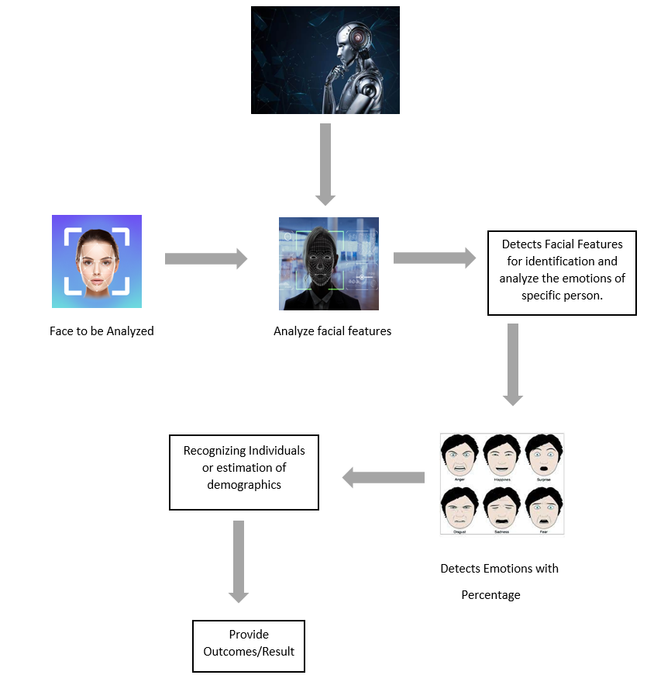

### **Explain the approach you choose**

* **Facial Recognition:** Use model to detect and recognize faces with a high degree of accuracy.
* **Expression Detection:** Apply emotion recognition models trained on datasets

### **Evaluate and justify the methodological choices you made**

* **Face Detection:** AI-Driven Face Analysis have proven to be highly effective in image recognition tasks. They are suitable for extracting key features from images, making them ideal for detecting facial landmarks and expressions.

1. **Breakdown Structure**

|  |  |
| --- | --- |
| **TOPIC** | **TASK** |
| 1. **Requirement Gathering and Analysis** | |
| Task 1.1 | Identify various system and their weakness |
| Task 1.2 | Collect the Data about approaches |
| Duration | 4 Weeks |
| 1. **Model Selection and Development** | |
| Task 2.1 | Use Deep Learning Model |
| Task 2.2 | Train AI model using advance approaches |
| Duration | 6 Weeks |
| 1. **Design and Validation** | |
| Task 3.1 | Identify the target audience and define the key functionalities that user needs. |
| Task 3.2 | Design user friendly interface for end user. |
| Task 3.3 | Design separate section for different functionalities such as camera input and historical data. |
| Duration | 10 Weeks |
| 1. **Facial Expression Analysis** | |
| Task 4.1 | Implement emotion classification model. |
| Task 4.2 | Calculate expression and display in percentage. |
| Duration | 12 Weeks. |
| 1. **Testing and Evaluation** | |
| Task 5.1 | Test Behavior of developed functions. |
| Task 5.2 | Checking validity and security of customer data. |
| Duration | 4 Weeks. |
| 1. **Monitoring and Maintenance** | |
| Task 6.1 | Implement error-handling mechanism. |
| Task 6.2 | Maintaining security and accuracy. |
| Duration | 5 Weeks |

## Project Time-Line

A Gantt chart outlines what aspects of the project will be completed and by when. A sample Gantt chart is shown in Figure 1.

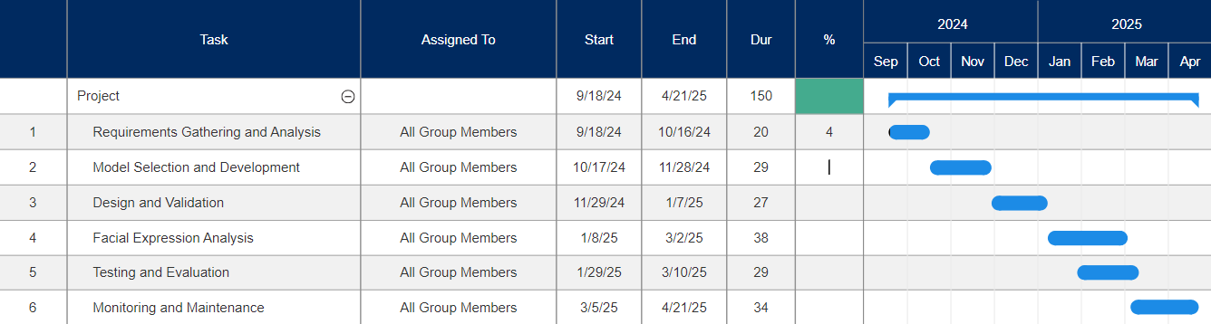

**Figure 1** **Project Ti****meline**

## References

### Naga, P., Marri, S. D., & Borreo, R. (2023). Facial emotion recognition methods, datasets and technologies: A literature survey. *Materials Today: Proceedings*, *80*, 2824-2828.

1. Peng, Z., Fu, R. Z., Chen, H. P., Takahashi, K., Tanioka, Y., & Roy, D. (2024). AI Applications in Emotion Recognition: A Bibliometric Analysis. In *SHS Web of Conferences* (Vol. 194, p. 03005). EDP Sciences.
2. Castellano, G., De Carolis, B., & Macchiarulo, N. (2023). Automatic facial emotion recognition at the COVID-19 pandemic time. *Multimedia Tools and Applications*, *82*(9), 12751-12769.